**Guía #2 de Arquitectura de Software**

**Juan Diego Pinzón Fontecha**

**Carlos Felipe Avilan Payares**

**Juan Esteban Agredo Santamaria**

**Facultad de Ingeniería, Universidad Manuela Beltrán**

**Arquitectura de Software**

**Carlos Eduardo Mojica Reyes**

**9 de marzo de 2025**

**Sprint Planning**

**Summary**

ERP for lawyers is an enterprise resource planning system designed to help law firms manage their administrative and operational processes efficiently. This software centralizes and automates various key functions to optimize the administration of a law firm, allowing for greater control, efficiency and organization in critical areas of the legal business.

ERP is made up of several essential modules that cover different aspects of business management:

* **Purchases/Inventories:** Allows you to manage the acquisition of goods and services, control stocks and optimize the logistics of supplies necessary for the operation of the firm.
* **Clients/Suppliers:** Facilitates the management of contacts, including clients and suppliers, ensuring proper management of business relationships.
* **HR/Payroll:** Manages the firm's human resources, allowing for employee management, payroll calculation and benefit control.
* **Accounting:** Manages the financial and tax aspects of the firm, allowing for the generation of accounting reports, account management and compliance with tax regulations.
* **Sales:** Automate the billing process, generating contracts and tracking services provided to customers.

**Introduction**

This document details the planning of Sprint 1 for the development of the ERP for lawyers. The activities necessary for the construction of the product backlog, definition of the scope of the user stories, planning of tests and assignment of roles within the team are established. The Sprint management will be carried out through Jira, ensuring efficient control of the progress of the project.

Link JIRA: <https://academia-team-xdjn4v7n.atlassian.net/jira/software/projects/SCRUM/boards/1/backlog>

Link Github: https://github.com/JuanDpf26/ArquiSoftware

1. **Build the product backlog. Remember that the product backlog should be  
   prioritized (You must use 2 ways to prioritize)**

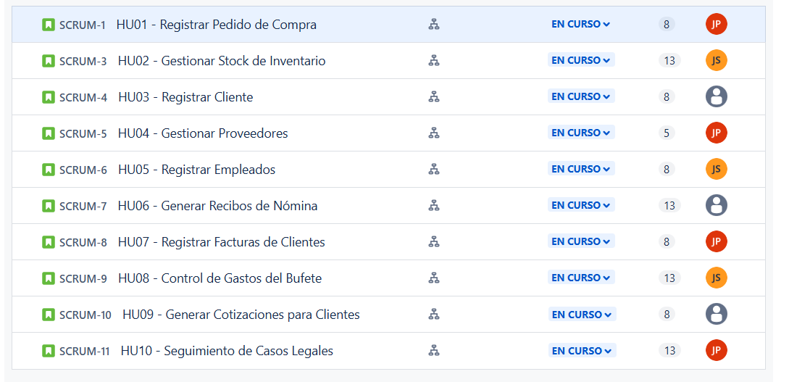

1. **Determine the “Definition of Done” established by the group for the development of the project.**

To ensure the quality and proper completion of each user story, the team agrees that a task will be "Done" when:

* Development of the requested functionality has been completed.
* Unit and integration tests have been performed and passed.
* The code is properly documented.
* A code review has been performed by another team member.
* The functionality is implemented in the test environment and validated by the team.

1. **Build the Sprint Backlog for the first Sprint. To do this**

a. Make a detailed specification of the stories selected for the sprint.

b. Prioritize those user stories with the greatest value for the end user.

c. Include at least 5 acceptance criteria for each story.

d. Determine the tasks necessary to complete the stories proposed for the sprint.

**HU01 - Register Purchase Order**

**As a system administrator**

**I want to: register purchase orders with supplier and product details.  
So that I can: Maintain control over acquisitions..**

**Acceptance Criteria:**

1. **Allow selecting a registered supplier.**
2. **Add products to the order with quantity and price.**
3. **Validate that the products exist in the catalog.**
4. **Save the order in "Pending approval" status.**
5. **Send notification to the purchasing department.**

**HU02 - Manage Inventory Stock**

**As an Inventory Operator**

**I want to: Update product stock when new orders arrive.  
So that I can: Maintain accurate inventory information.**

**Acceptance Criteria:**

1. **Stock Display: The system should show a list of products with current stock levels.**
2. **Stock Update: I must be able to enter the quantity received for each product.**
3. **Validation: The updated stock level must not be negative.**
4. **Modification History: The system should generate a history of stock changes.**
5. **Low Stock Alerts: The system should send an alert if stock is below the minimum level.**

**HU03 - Register Customer**

**As an Administrator**

**I want to: Register new clients with their tax and contact details.  
So that I can: Manage invoicing and services.**

**Acceptance Criteria:**

1. **Data Entry: I must be able to enter the client's name, tax ID, address, and contact details.**
2. **Unique Validation: The tax ID must be unique in the system.**
3. **Client Management: I must be able to modify and delete registered clients.**
4. **Storage: The data must be saved in the database.**
5. **Confirmation: A success message should be displayed upon completing the registration.**

**HU04 - Manage supplier**

**As an Administrator**

**I want to: Manage supplier information.  
So that I can: Facilitate the purchase of supplies and services.**

**Acceptance Criteria:**

1. **Supplier Registration: I must be able to enter new supplier data.**
2. **Duplicate Validation: The system must prevent duplicate information.**
3. **Supplier Management: I must be able to modify and delete suppliers.**
4. **Supplier Listing: The system should display a list of registered suppliers.**
5. **Integration: The supplier module should be integrated with the purchasing module.**

**HU05 - Register Employees**

**As an HR Manager**

**I want to: Register new employees with their contract details.  
So that I can: Manage payroll and leave requests.**

**Acceptance Criteria:**

1. **Employee Data Entry: I must be able to enter the employee's name, position, salary, and hiring date.**
2. **Unique Identification: Each employee must have a unique identification number.**
3. **Employee Management: I must be able to modify and delete employee records.**
4. **Storage: The employee information must be saved in the database.**
5. **Employee Listing: The system should display a list of active employees.**

**HU06 - Generate Payroll Receipts**

**As a Payroll Administrator**

**I want to: Generate automatic payment receipts for employees.  
So that I can: Ensure timely salary payments.**

**Acceptance Criteria:**

1. **Salary Calculation: The payroll must be calculated based on worked hours and deductions.**
2. **PDF Generation: The system should generate a payment receipt in PDF format.**
3. **Email Notification: The payment receipt should be sent to the employee via email.**
4. **Payment History: The system must store a history of all payments.**
5. **Duplicate Validation: The system should ensure that there are no duplicate payments.**

**HU07 - Register Customer Invoices**

**As an Accountant**

**I want to: Register client invoices with payment details.  
So that I can: Maintain accurate financial records.**

**Acceptance Criteria:**

1. **Invoice Entry: I must be able to enter the client, amount, and payment date.**
2. **Validation: The amount must be greater than zero.**
3. **Client Association: Each invoice must be linked to a registered client.**
4. **Status Tracking: The invoice must be saved as "Pending" or "Paid."**
5. **Report Generation: The system should generate a monthly invoicing report.**

**HU08 - Control of Firm Expenses**

**As a Financial Administrator**

**I want to: Register and categorize law firm expenses.  
So that I can: Maintain detailed budget control.**

**Acceptance Criteria:**

1. **Expense Entry: I must be able to register expenses with date, amount, and category.**
2. **Validation: The amount must be a positive number.**
3. **Report Generation: The system should generate monthly and annual reports.**
4. **Exporting Data: The data should be exportable to Excel/PDF.**
5. **Budget Alerts: The system should send alerts if an expense exceeds the assigned budget.**

**HU09 - Generate Quotes for Clients**

**As a Lawyer**

**I want to: Generate personalized quotes for clients.  
So that I can: Facilitate the negotiation of legal services.**

**Acceptance Criteria:**

1. **Quote Creation: I must be able to enter services, rates, and conditions.**
2. **Automatic Calculation: The system should calculate the total amount automatically.**
3. **PDF Generation: The system should generate a quote in PDF format.**
4. **Email Notification: The quote should be sendable via email.**

**HU10 - Seguimiento de Casos Legales**

**As a Lawyer**

**I want to: Register and track active legal cases.  
So that I can: Organize case management.**

**Acceptance Criteria:**

1. **Client and Lawyer Association: Each case must be linked to a client and a responsible lawyer.**
2. **Status Updates: The system should allow updating the case status (Open, In Progress, Closed).**
3. **Document Attachment: I must be able to attach related documents to each case.**
4. **Deadline Alerts: The system should generate alerts for key dates.**
5. **Dashboard Overview: The system should display a summary of active cases on the dashboard.**
6. **Sprint test planning.  
   Test cases on selected platform (minimum 5 cases per HU)**

**HU01 - Register Purchase Order**

Test Case 1: Verify that a purchase order can be successfully registered with valid data.  
Test Case 2: Ensure that required fields (supplier, items, quantities, price) are validated.  
Test Case 3: Check that an error message appears when mandatory fields are missing.  
Test Case 4: Validate that duplicate purchase orders cannot be registered.  
Test Case 5: Confirm that purchase order details are stored correctly in the database.

**HU02 - Manage Inventory Stock**

Test Case 1: Verify that inventory stock is updated when items are added or removed.  
Test Case 2: Ensure that stock cannot be reduced below zero.  
Test Case 3: Validate that stock levels trigger alerts when below the minimum threshold.  
Test Case 4: Check that inventory adjustments are logged correctly.  
Test Case 5: Confirm that users can search and filter inventory items.

**HU03 - Register Client**

Test Case 1: Verify that a new client can be successfully registered with valid data.  
Test Case 2: Ensure that required fields (name, email, phone) are validated.  
Test Case 3: Check that duplicate clients cannot be registered.  
Test Case 4: Validate that invalid email formats are not accepted.  
Test Case 5: Confirm that client details are correctly stored in the database.

**HU04 - Manage Suppliers**

Test Case 1: Verify that new suppliers can be added.  
Test Case 2: Ensure that existing suppliers can be updated.  
Test Case 3: Check that suppliers can be deleted only if no pending orders exist.  
Test Case 4: Validate that supplier search and filtering work correctly.  
Test Case 5: Confirm that duplicate supplier entries are prevented.

**HU05 - Register Employees**

Test Case 1: Verify that an employee can be successfully registered.  
Test Case 2: Ensure that required fields (name, ID, department, role) are validated.  
Test Case 3: Check that duplicate employee records cannot be created.  
Test Case 4: Validate that invalid email and phone formats are rejected.  
Test Case 5: Confirm that employee details are stored correctly in the database.

**HU06 - Generate Payroll Receipts**

Test Case 1: Verify that payroll receipts can be generated for all employees.  
Test Case 2: Ensure that the salary calculation is accurate.  
Test Case 3: Check that deductions and bonuses are applied correctly.  
Test Case 4: Validate that payroll receipts can be downloaded in PDF format.  
Test Case 5: Confirm that payroll history is correctly stored for each employee.

**HU07 - Register Client Invoices**

Test Case 1: Verify that a new invoice can be created.  
Test Case 2: Ensure that required fields (customer, items, total amount) are validated.  
Test Case 3: Check that invoice numbers are unique.  
Test Case 4: Validate that invoices can be retrieved by customer or date.  
Test Case 5: Confirm that invoices can be exported as PDF.

**HU08 - Law Firm Expense Control**

Test Case 1: Verify that expenses can be recorded with date, category, and amount.  
Test Case 2: Ensure that only authorized users can register expenses.  
Test Case 3: Check that expense reports can be generated.  
Test Case 4: Validate that incorrect amounts (negative values) are not accepted.  
Test Case 5: Confirm that total expenses are updated in real-time.

**HU09 - Generate Client Quotations**

Test Case 1: Verify that a quotation can be generated with itemized costs.  
Test Case 2: Ensure that required fields (customer, items, validity date) are validated.  
Test Case 3: Check that quotations can be edited before finalization.  
Test Case 4: Validate that quotations can be sent via email.  
Test Case 5: Confirm that quotation history is maintained.

**HU10 - Legal Case Tracking**

Test Case 1: Verify that new legal cases can be registered.  
Test Case 2: Ensure that case status updates are tracked correctly.  
Test Case 3: Check that assigned lawyers receive notifications.  
Test Case 4: Validate that legal case details are securely stored.  
Test Case 5: Confirm that reports can be generated for ongoing cases.

1. **Identify the strengths and weaknesses of each team member. It is suggested to assign roles to lead technical, organizational, and quality aspects. These elements are definitive in the success of the project and should be considered before starting development. Complete the following table mentioning the strategies established by the group in each case.**

|  |  |  |
| --- | --- | --- |
|  | **STRATEGY** | **RESPONSIBLE** |
| **Technical Aspect** | |  | | --- | | - Implement best coding practices. | | - Ensure system performance and security. | | - Manage database optimization. | | Juan Estaban Agredo |
| **Communication** | |  | | --- | | Facilitate internal team coordination. | | - Ensure clear documentation and reporting. | | - Act as the bridge between stakeholders and developers. | | Carlos Felipe Avilan |
| **Quality Assurance** | |  |  | | --- | --- | | - Define and execute test cases. |  | | - Ensure compliance with quality standards. |  | | - Oversee bug tracking and resolution. |  | | Juan Diego Pinzón Fontecha |

1. **Work Schedule**

**Work Schedule - Sprint 1**

* **Duration:** March 9 - March 16 (7 working days)  
  **User Stories:** 10  
  **Scrum Team:** (Assign team members as needed)

